### **1. Context and Overview**

The Stock Car web application is a comprehensive tool tailored for managing and viewing information about used cars. It is designed to streamline the buying and selling processes for potential buyers and various organizations such as car dealerships, rental companies, and car depots. By offering a centralized platform, the application enables users to efficiently manage a diverse inventory of vehicles.

The primary features of the app include viewing a complete list of available cars, searching for specific vehicles based on multiple criteria (such as make, model, year, and price), and adding or removing cars from the system's database. These functions not only simplify inventory tracking but also enhance transparency and accessibility for stakeholders.

Potential buyers can browse through cars with ease, comparing specifications and prices, while businesses can update their inventories in real time, ensuring that only relevant, up-to-date listings are visible to users. This digitized approach helps eliminate the inefficiencies of traditional, manual methods of car inventory management, offering a streamlined solution for handling vehicle data.

Moreover, the application is scalable, allowing for easy customization based on the needs of small dealerships or larger organizations. It can accommodate various levels of car inventory, making it flexible for different business models. Although the current version focuses on viewing and managing cars, future iterations could include additional features such as detailed vehicle history, user authentication, and customer inquiry systems, further expanding the app’s utility.

This all-encompassing platform provides a user-friendly interface for a wide range of car-related needs, enhancing the overall experience for both businesses and customers alike.

#### **Application Features:**

1. **View a List of Cars**:  
   Users can easily access a complete list of all cars currently in stock, displayed in a structured and user-friendly list format. This feature is valuable for car dealerships, buyers, and warehouse managers, helping them keep track of available vehicles at a glance. The list is designed to offer a clear overview of essential car details, making it easy to browse through the inventory.
2. **View Car Details**:  
   The app provides users with the ability to click on a specific car from the list to view more detailed information. Key details such as the make, model, year, kilometers driven, price, and other specifications are presented in a clear, concise manner. This feature is crucial in automotive sales and rentals, as it enables staff and customers to assess car features comprehensively before making a decision.
3. **Search Functionality**:  
   One of the most critical aspects of the Stock Car application is its search functionality. Users can search for cars based on various parameters such as make, model, year, price range, or condition. This feature significantly improves the speed and accuracy of processes like customer inquiries or internal stock verification, making it easier for users to find specific vehicles that meet their needs.
4. **Add a New Car**:  
   Users can input new cars into the system by filling out necessary details, allowing seamless updates to the inventory database. This feature ensures that the inventory remains current and accurate, especially after new stock arrivals.
5. **Delete a Car**:  
   Outdated or sold vehicles can be easily removed from the inventory using this feature. This ensures that the inventory remains current, preventing clutter and confusion by displaying only the cars that are still available for sale or rental. By keeping the system clean, users can rely on the application for accurate and relevant information.

#### 

#### **Context of Use:**

The **primary context** of the Stock Car application is in environments where car inventory management is a daily task. For example, **car dealerships** can use the application to keep track of the cars in their showroom, updating the inventory when new models arrive or existing models are sold. Additionally, **automobile warehouses** can rely on the app to maintain an accurate, real-time inventory of all cars in stock, ensuring operational efficiency and quick access to information.

**Rental companies** can also benefit from using Stock Car, as they manage fleets of cars. This system could keep track of which vehicles are available, which have been rented out, and manage maintenance schedules based on detailed car information.

In each of these settings, **efficiency, accuracy, and reliability** are paramount. Therefore, thorough testing of the application across various layers is critical to ensure it functions as expected and is resilient to issues like bugs or security vulnerabilities.

#### **Importance of Testing:**

Testing plays a crucial role in ensuring that the **Stock Car application** delivers the reliability and performance expected in real-world use. Some of the **key reasons for testing** include:

1. **Reliability**:  
   In settings like car dealerships, incorrect inventory data can lead to lost sales or customer dissatisfaction. Testing ensures that features like **adding new cars** or **deleting sold cars** work as expected, maintaining an accurate inventory at all times.
2. **Security**:  
   Since the application manages sensitive data, such as car details and possibly customer information, it must be secure against threats like **SQL injection** or **cross-site scripting (XSS)**. Security testing ensures the system can withstand external threats.
3. **Performance**:  
   The app needs to handle a potentially large number of cars in its database without lagging or crashing. Testing can identify bottlenecks and improve the system's performance to ensure **smooth operation**, even under heavy loads.
4. **Usability**:  
   Users need a straightforward, easy-to-navigate interface. Testing the **user experience** ensures that the application is intuitive and easy to use, minimizing errors caused by confusion or poorly designed features.

Testing at different layers is vital:

* **Unit Testing** validates that individual components (e.g., adding a car) work as intended.
* **Integration Testing** ensures that different parts of the system, such as the frontend and backend, interact correctly.
* **Security Testing** verifies that the system is safe from common vulnerabilities.
* **Database Testing** ensures that data is handled correctly and remains consistent across the application.
* **System Testing** evaluates the application as a whole, confirming its ability to handle real-world conditions.

### 

### **2. Test Plan Development**

#### **Testing Strategy Overview:**

To ensure the reliability and functionality of the Stock Car application, a comprehensive testing strategy is essential. The testing plan covers various critical areas to guarantee that the application performs as expected under different scenarios. This strategy includes **unit tests, integration tests, security tests, database tests, and system tests**, each designed to validate specific layers of the application and identify potential issues early in development.

#### **1. Unit Testing:**

**Tool**: JUnit, Mockito

Unit tests are critical for ensuring the correctness of individual methods and functions within the Stock Car application by testing them in isolation. For this application, unit testing will focus on the core functionality of key features, ensuring they operate as expected when used independently. Some of the main features covered by unit tests include:

* Adding a car to the system.
* Deleting a car from the list.
* Searching for cars.

**Why Unit Tests Are Necessary**:  
Unit tests are essential because they ensure that each individual feature works correctly on its own, independent of other parts of the system. For instance, when adding a car, unit tests will confirm that the data is properly validated, ensuring fields are correctly populated and that the car details are successfully inserted into the database without error.

JUnit is chosen due to its popularity and effectiveness in automating the testing of individual Java methods. Mockito is used to mock dependencies and isolate the behavior of specific components during testing, ensuring that the tests are both focused and reliable. This approach allows developers to catch bugs early in the development cycle, making the application more stable and reducing the likelihood of system-wide errors.

#### **2. Integration Testing:**

**Tool**: JUnit, Selenium

Integration tests ensure that different parts of the application work together as expected. For instance, when a car is added through the UI, integration testing ensures that the data is passed correctly to the backend and stored in the database.

**Why Integration Tests Are Necessary**:  
It is crucial to ensure that the UI interacts correctly with the backend. For example, after adding a car through the web interface, integration tests will confirm that the data reaches the database correctly. JUnit is ideal for testing the backend, while Selenium automates user actions to test the UI.

#### **3. Security Testing:**

Security tests are designed to identify vulnerabilities within the Stock Car application, particularly focusing on common attack vectors like SQL injection and cross-site scripting (XSS). These tests are critical for ensuring the protection of the application's data and preventing unauthorized access or manipulation.

**Why Security Tests Are Necessary**:  
Web applications, especially those handling important data such as car inventories, are prime targets for various types of cyberattacks. Security testing ensures that the Stock Car application is hardened against potential threats, safeguarding sensitive data and ensuring that the system remains secure for both users and administrators.

Since the application interacts with a database, it is essential to test for vulnerabilities like SQL injection to prevent attackers from gaining unauthorized access to critical data. Similarly, XSS protection is crucial to protect users from being affected by malicious scripts that could compromise their personal data or the application’s functionality. These tests help ensure that the Stock Car application is compliant with best security practices, reducing the risk of potential attacks and breaches.

**4. Database Testing:**

**Tool**: SQL

Database tests ensure that the application's data handling is correct, confirming that data is saved, retrieved, and modified as expected. Tests will check if car data is consistent across the application after being added or deleted.

**Why Database Tests Are Necessary**:  
Since the Stock Car application relies heavily on managing inventory data, accurate database transactions are critical. For example, deleting a car must remove it from the database, and retrieving data must reflect real-time information. DBUnit is effective for testing the integrity of database operations.

#### **5. System Testing:**

**System tests** focus on evaluating the entire Stock Car application in a fully integrated, real-world environment. These tests simulate actual user interactions and workflows to ensure that the application performs all functions smoothly and without errors. System testing covers the complete end-to-end functionality of the application, verifying that it works seamlessly when accessed by users.

**Why System Tests Are Necessary**:  
System tests are essential because they validate the end-to-end user experience, ensuring that the Stock Car application behaves as intended in real-world scenarios. These tests confirm that all features and functionalities are integrated correctly and that the system processes user actions efficiently and accurately.

A flawless user experience is critical for any application, especially one that manages inventory and sales data. System testing helps ensure that the application handles various tasks—like adding, deleting, and searching for cars—without crashes, errors, or slowdowns. It ensures the application is robust, reliable, and ready for deployment, providing confidence that it will perform well when used by customers, dealerships, and administrators.

**3. Unit Tests**

#### **Test Case 1: Testing the Add Car Functionality**

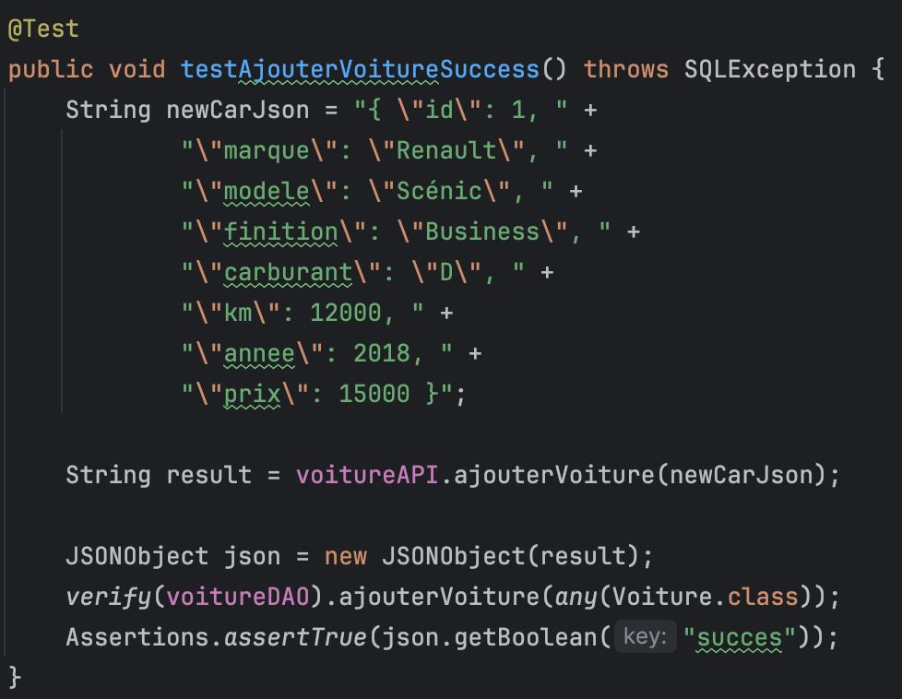

* **Test ID:** CA-T-01
* **Objective:** Verify the behavior of the "Add Car" functionality.
* **Test Method:** Unit Test
* **Prerequisites:** Installation of the Stock Car application, IntelliJ, JUnit, Mockito, and Maven.
* **Setup:**
  1. Create a mock object for VoitureDAO to avoid interactions with the real database.
  2. Mock a valid JSON string representing a car object with correct fuel type.
  3. Use Mockito to verify interactions with voitureDAO.
* **Steps:**
  1. Pass the JSON string to the voitureAPI.ajouterVoiture() method.
  2. Verify that ajouterVoiture method of VoitureDAO is called correctly.
  3. Assert that the returned JSON response contains "succes": true.
* **Expected Result:** The car is successfully added, and the response contains a success flag.
* **Outcome:** The test passed, confirming that the system successfully adds a car when all fields are valid.

#### **Test Case 2: Testing Add Car Failure When Fuel Type is Incorrect**

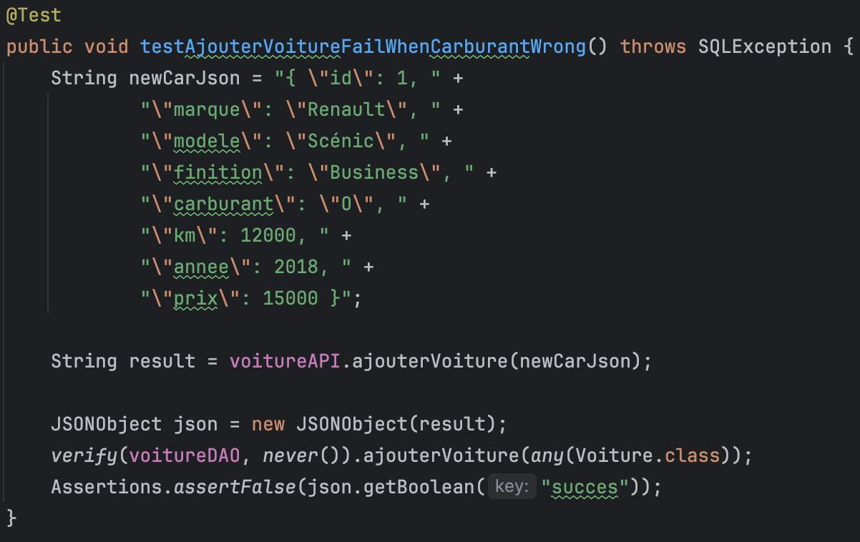

* **Test ID:** CA-T-02
* **Objective:** Test the failure scenario when an invalid fuel type is provided.
* **Test Method:** Unit Test
* **Prerequisites:** Same as Test Case 1.
* **Setup:**
  1. Mock a JSON string with an invalid fuel type.
  2. Ensure no interaction occurs with the voitureDAO when validation fails.
* **Steps:**
  1. Call voitureAPI.ajouterVoiture() with invalid data.
  2. Verify that voitureDAO.ajouterVoiture() is **not** invoked.
  3. Assert that the returned JSON response contains "succes": false.
* **Expected Result:** The car is not added, and the system returns an error due to invalid fuel type.
* **Outcome:** The test passed, confirming the validation logic correctly handles invalid input.

#### **Test Case 3: Testing Delete Car Functionality**

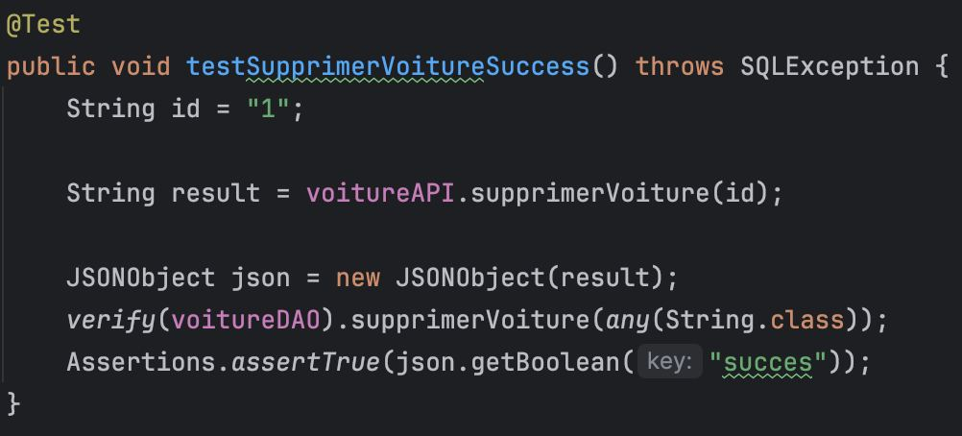

* **Test ID:** CA-T-03
* **Objective:** Verify the "Delete Car" functionality.
* **Test Method:** Unit Test
* **Prerequisites:** Same as Test Case 1.
* **Setup:**
  1. Mock voitureDAO.supprimerVoiture() method to simulate the car removal process.
* **Steps:**
  1. Call voitureAPI.supprimerVoiture() with a valid car ID.
  2. Verify that voitureDAO.supprimerVoiture() is invoked.
  3. Assert that the returned JSON response contains "succes": true.
* **Expected Result:** The car is successfully removed from the system, and the response confirms the success.
* **Outcome:** The test passed, confirming the car deletion logic works as expected.

#### **Test Case 4: Testing Delete Car Failure When SQLException Occurs**

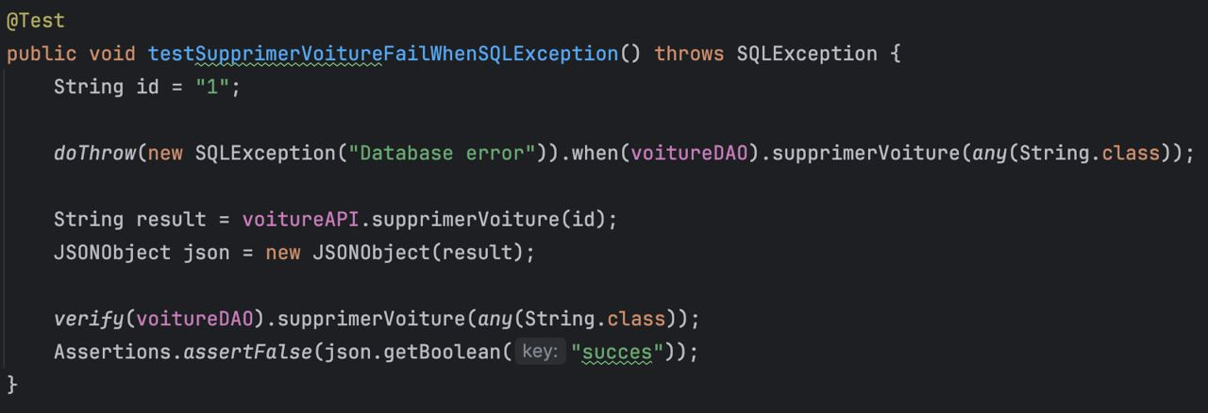

* **Test ID:** CA-T-04
* **Objective:** Handle the exception during car deletion.
* **Test Method:** Unit Test
* **Prerequisites:** Same as Test Case 1.
* **Setup:**
  1. Simulate an SQL exception when deleting a car.
* **Steps:**
  1. Call voitureAPI.supprimerVoiture() and trigger an SQL exception.
  2. Assert that voitureDAO.supprimerVoiture() was called.
  3. Assert that the returned JSON response contains "succes": false.
* **Expected Result:** The system returns an error message due to the SQL exception, and no deletion occurs.
* **Outcome:** The test passed, verifying that the system handles database errors correctly.

#### **Test Case 5: Testing Get All Cars Functionality**

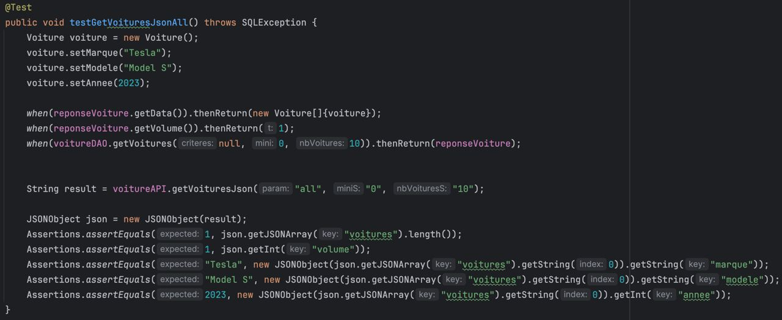

* **Test ID:** CA-T-05
* **Objective:** Verify the retrieval of all cars.
* **Test Method:** Unit Test
* **Prerequisites:** Same as Test Case 1.
* **Setup:**
  1. Mock reponseVoiture.getData() and reponseVoiture.getVolume() to return a list of cars.
  2. Mock voitureDAO.getVoitures() to simulate the car retrieval.
* **Steps:**
  1. Call voitureAPI.getVoituresJson() with parameters to retrieve all cars.
  2. Verify the correct car details are returned in the JSON response.
  3. Assert that the response includes the correct number of cars.
* **Expected Result:** All cars are successfully retrieved, and the JSON response includes the correct details.
* **Outcome:** The test passed, confirming that the car retrieval feature works as expected.

#### **Test Case 6: Testing Get Car by ID Functionality**

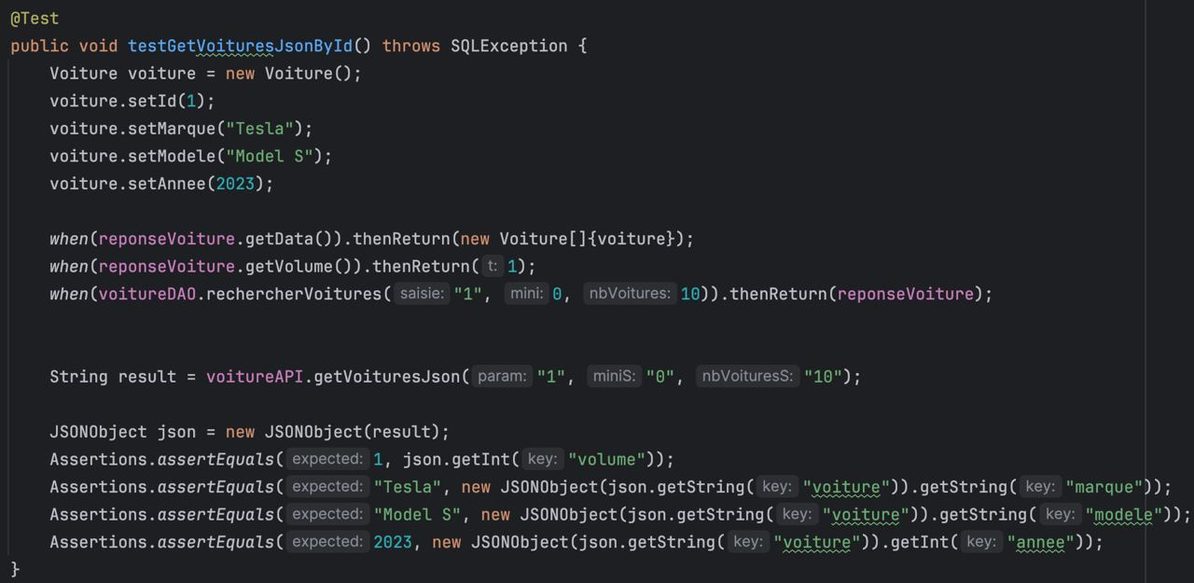

* **Test ID:** CA-T-06
* **Objective:** Test the retrieval of a specific car by its ID.
* **Test Method:** Unit Test
* **Prerequisites:** Same as Test Case 1.
* **Setup:**
  1. Mock a Voiture object and simulate its retrieval by ID through voitureDAO.
* **Steps:**
  1. Call voitureAPI.getVoituresJson() with a car ID.
  2. Verify the correct car is retrieved and returned in the JSON response.
  3. Assert that the JSON contains the expected car details (make, model, etc.).
* **Expected Result:** The correct car is returned based on its ID.
* **Outcome:** The test passed, verifying that the system retrieves the car by ID correctly.

#### **Test Case 7: Testing Search Car by Name Functionality**

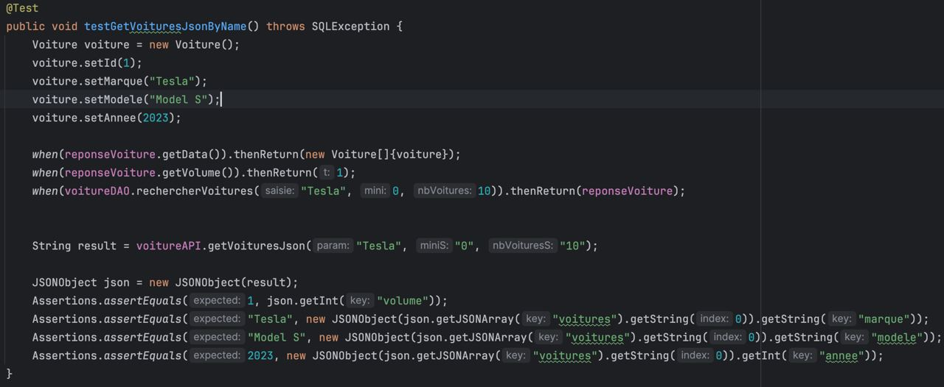

* **Test ID:** CA-T-07
* **Objective:** Test the search functionality for cars based on the name.
* **Test Method:** Unit Test
* **Prerequisites:** Same as Test Case 1.
* **Setup:**
  1. Mock VoitureDAO.rechercherVoitures() to return cars that match the search criteria.
* **Steps:**
  1. Call voitureAPI.getVoituresJson() with a name parameter.
  2. Verify the cars returned match the name.
  3. Assert that the returned data contains the correct cars.
* **Expected Result:** Cars matching the specified name are returned successfully.
* **Outcome:** The test passed, confirming that the search by name feature works as intended.

**All tests pass:**

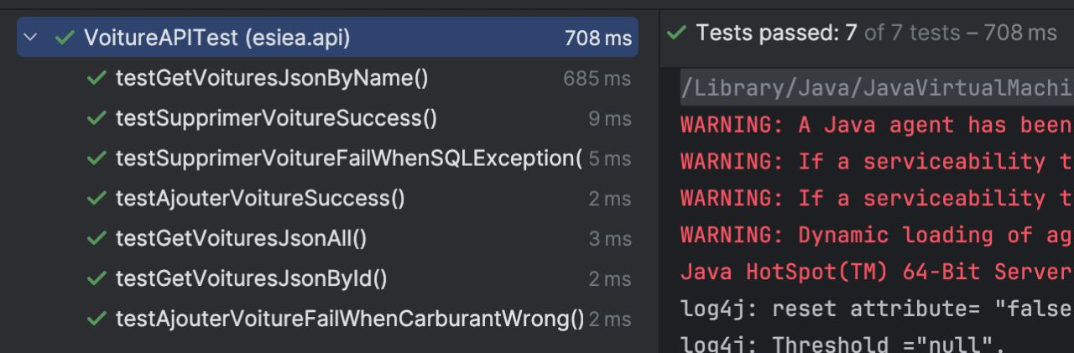

### **Conclusion**

These unit tests cover the key functionalities of the Stock Car application, ensuring that features such as adding, deleting, and searching for cars behave correctly. Thorough testing guarantees the application's reliability, accuracy, and performance in real-world scenarios.

**4. Database Tests**

#### **Test Case 1: Adding a Car to the Database**

* **Test ID:** DB-T-01
* **Objective:** Verify that a new car is correctly added to the database using an SQL INSERT query.
* **Prerequisites:** Access to the database with the Voiture table created.
* **Query Used:**



**Steps:**

1. **Before Query**: data before the insert operation.

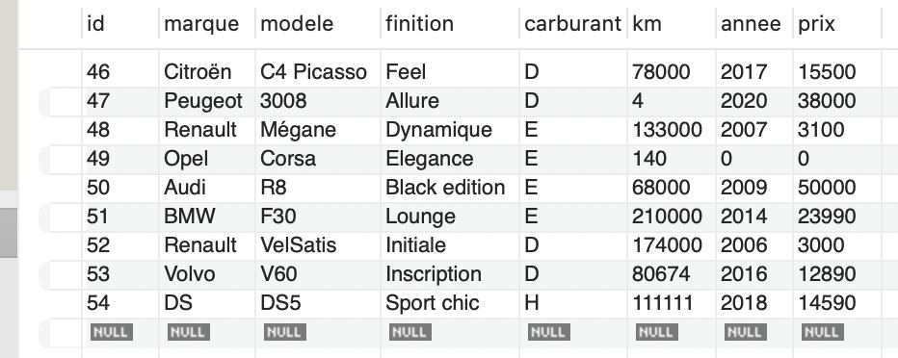

1. **Execute the Query**: Run the above SQL INSERT query to add a test car.



1. **After Query**: the Voiture table after the query to verify that the new car has been added.

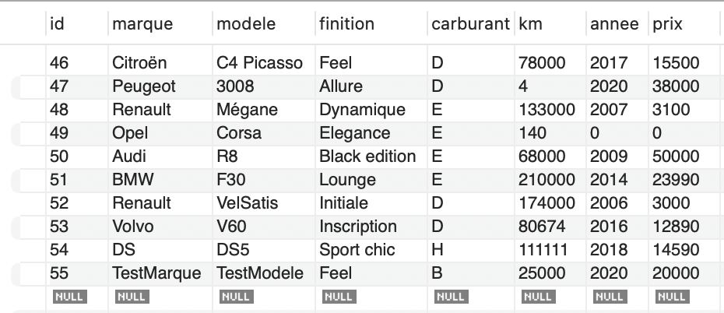

* **Expected Result:** The car with the details ("TestMarque", "TestModele", "Feel", "В", 25000, 2020, 20000) should appear in the table after running the query
* **Outcome:** The test passed.

#### **Test Case 2: Deleting a Car from the Database**

* **Test ID:** DB-T-02
* **Objective:** Verify that a car is correctly deleted from the database using an SQL DELETE query.
* **Prerequisites:** The database should contain a car record with a known id that will be deleted during the test.
* **Query Used:**

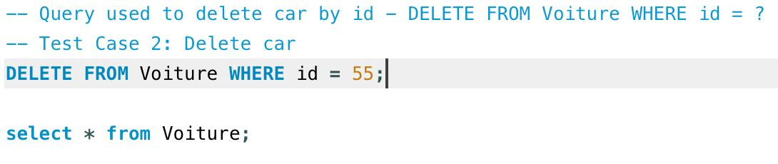

**Steps:**

1. **Before Query**: data before the delete operation.

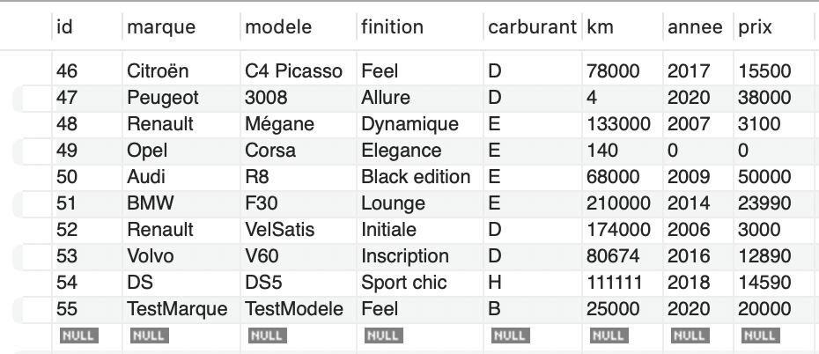

1. **Execute the Query:** Run the SQL DELETE query to remove the car with id = 55 from the table.



1. **After Query:** Voiture table **after** the query to verify that the car with id = 55 has been successfully removed.

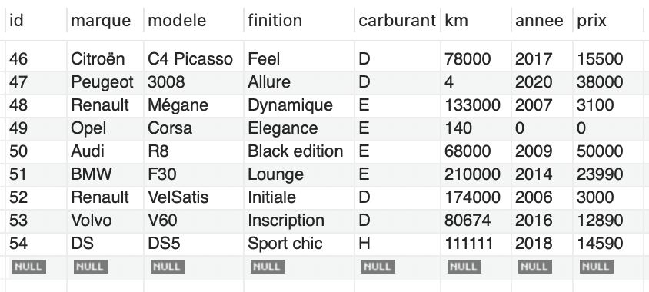

* **Expected Result:** After running the query, the car with id = 55 should no longer appear in the table.
* **Outcome:** The test passed.

### **Test Case 4: Searching for a Car by ID**

* **Test ID:** DB-T-04
* **Objective:** Verify that the car with a specific id can be correctly retrieved from the database using an SQL SELECT query.
* **Prerequisites:** The database must contain a car with id = 50 or any other known id for testing purposes.
* **Query Used:**



**Steps:**

1. **Before Query:** Ensure that there is a car record in the database with id = 50.



1. **Execute the Query:** Run the SQL SELECT query to search for the car with id = 50.



1. **After Query: c**ar’s details such as marque, modele, finition, carburant, km, annee, and prix.

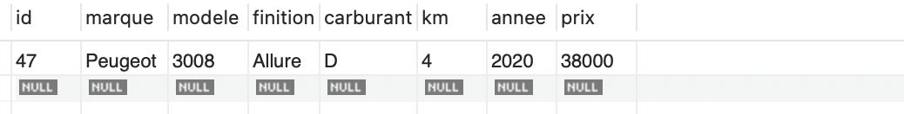

* **Expected Result:** The car with id = 50 should be retrieved successfully, and its details (such as marque, modele, km, etc.) should match the data stored in the Voiture table.
* **Outcome:** The test passed.

### **Test Case 5: Searching for Cars by Marque**

* **Test ID:** DB-T-05
* **Objective:** Verify that cars can be correctly retrieved from the database by their marque using an SQL SELECT query.
* **Prerequisites:** The database should contain one or more car records with the marque = 'Volvo' or another known brand.
* **Query Used:**



**Steps:**

1. **Before Query:** Ensure there are cars with the marque = 'Volvo'



1. **Execute the Query:** Run the SQL SELECT query to retrieve all cars where marque = 'Volvo'.



1. **After Query:** the result should return all cars with the specified marque.

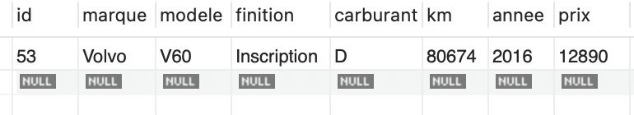

* **Expected Result:** All cars with the marque = 'Volvo' should be successfully retrieved, and the query result should display the relevant car details (e.g., id, modele, annee, etc.).
* **Outcome:** The test passed.

### **Conclusion**

The database tests performed on the Stock Car application validate the correct functionality of critical SQL operations, ensuring that the application's interaction with the database is reliable and accurate. The tests covered adding, deleting, and searching for cars, confirming that data manipulation occurs as expected.

**5. Security tests**

#### **Security Test Case 1: SQL Injection Test**

* **Test ID: SEC-T-01**
* **Objective:** Verify that the application is protected against SQL injection attacks, which could otherwise allow an attacker to manipulate the database by executing malicious SQL code.
* **Test Method:** Input malicious SQL code into the car search functionality to simulate an SQL injection attempt.
* **Malicious Code:**

'; DROP TABLE cars; --

* **Steps:**

1. Insert the malicious SQL code ('; DROP TABLE cars; --) into the car search input field of the application.

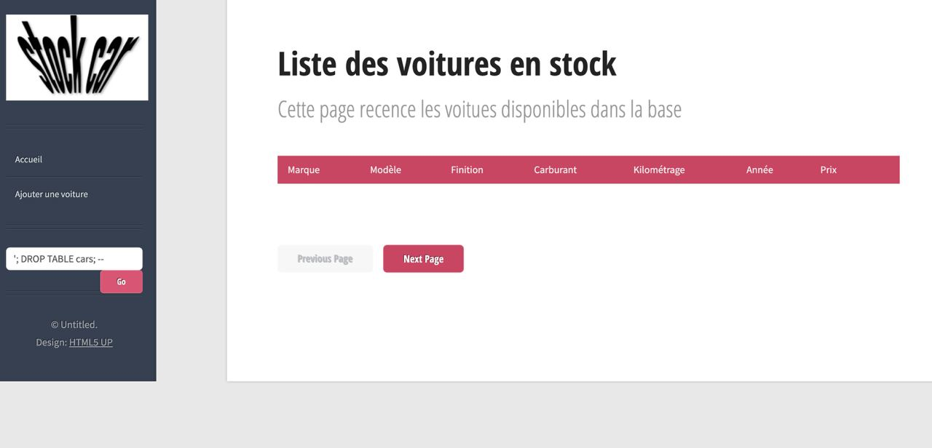

1. Execute the search request and monitor the system’s response.



1. Verify whether the cars table remains intact and data is still accessible after the malicious input is submitted.

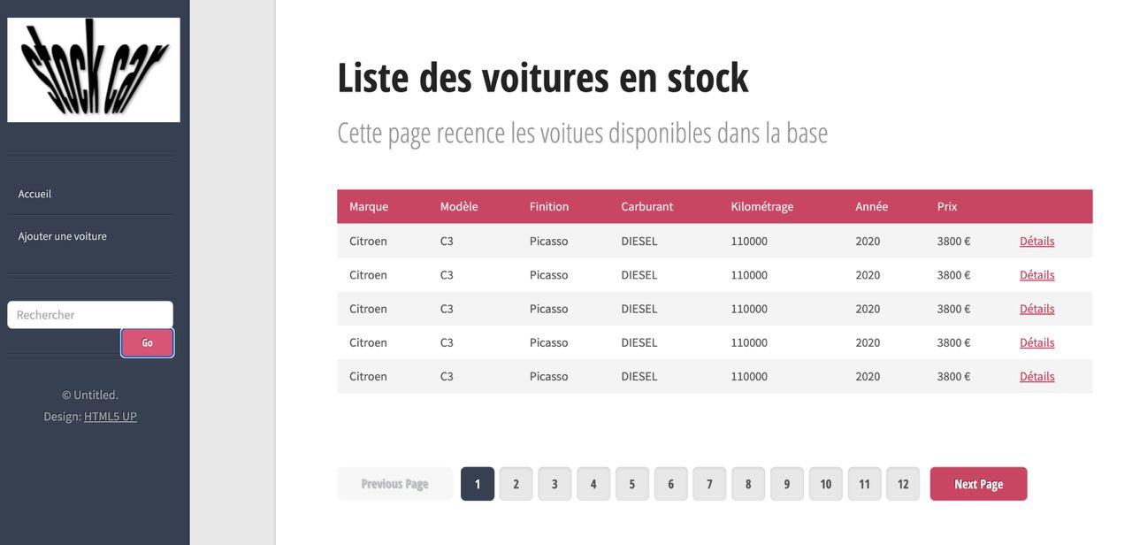

* **Expected Result:** The application should neutralize the SQL injection attempt, and the cars table should not be affected by the malicious input.
* **Actual Result: T**he cars table was **not** deleted, and the search functionality continued to work properly after submitting the malicious input. The application safely handled the SQL injection attempt without compromising the database.
* **Outcome:** The test passed, confirming that the application is resilient to SQL injection attacks. The malicious SQL code did not execute, and no harm was done to the database

#### **Security Test Case 2: Cross-Site Scripting (XSS) Test**

* **Test ID:** SEC-T-02
* **Objective:** Verify that the application is protected against Cross-Site Scripting (XSS) attacks, where an attacker might inject malicious scripts into web pages viewed by other users.
* **Test Method:** Input a malicious JavaScript code snippet into a text field in the application and observe whether it is executed or neutralized.
* **Malicious Code:**

**<script>alert('XSS')</script>**

* **Steps:**

1. Insert the above JavaScript code into a text input field, such as the car search or a comment section, to simulate an XSS attempt.

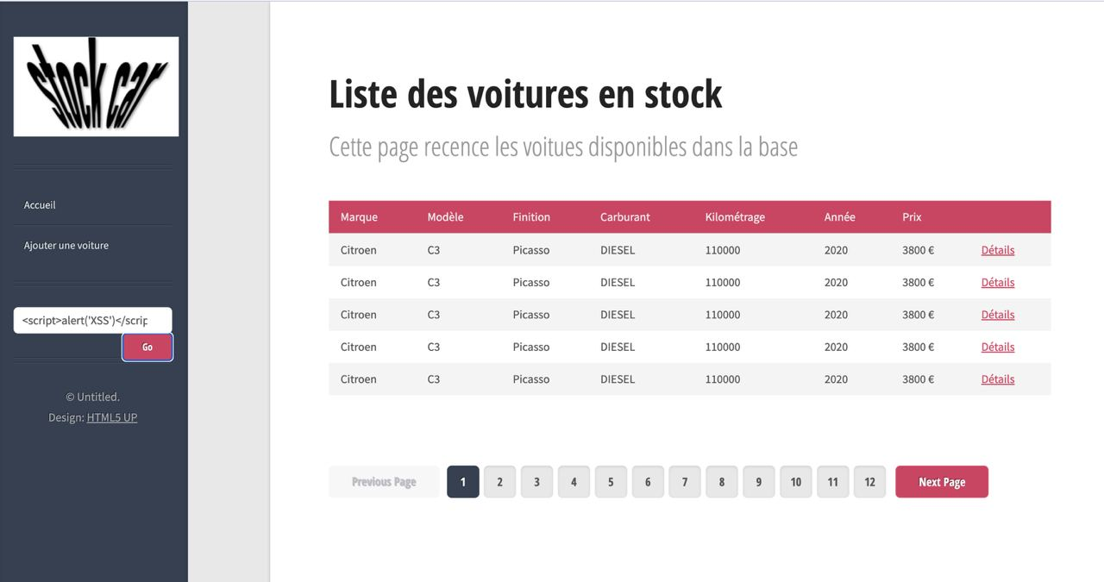

1. Submit the form and observe whether the code is executed by the browser.



1. Check if any alert box is displayed or if the code is reflected in the application output as plain text.

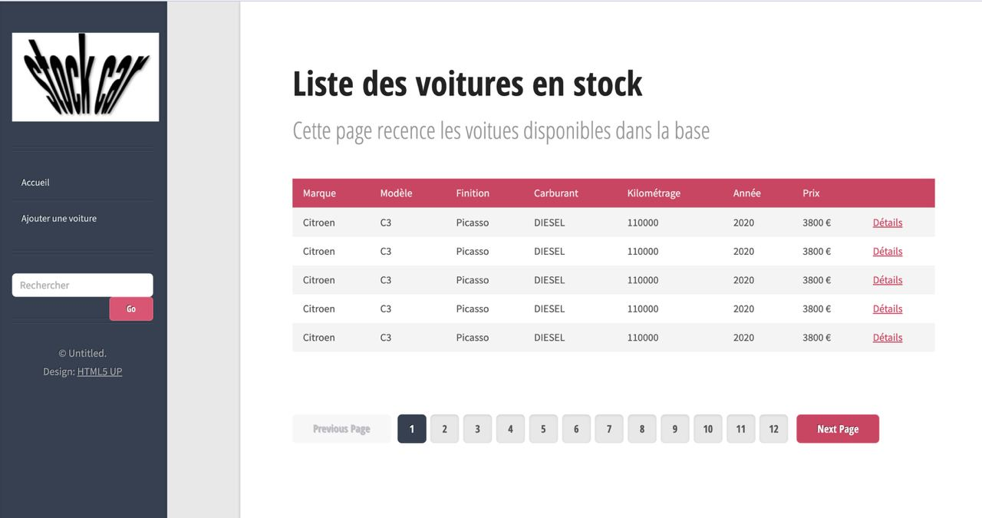

* **Expected Result:** The malicious script should not be executed, and no alert should be displayed. The input should be sanitized and safely rendered or rejected.
* **Actual Result:** The script was not executed, and no alert box was shown. The application properly handled the XSS attempt, and the malicious code did not run.
* **Outcome:** The test passed, confirming that the application is protected against XSS attacks. The malicious JavaScript code was neutralized, and the system did not execute it.

### **Conclusion**

The security tests conducted on the Stock Car application demonstrate that the system is well-protected against common web vulnerabilities, such as SQL injection and Cross-Site Scripting (XSS). Here's a summary of the key results:

1. **SQL Injection Test:**The test successfully confirmed that the application is resilient to SQL injection attacks. The malicious SQL code ('; DROP TABLE cars; --) was not executed, and the database remained intact. This ensures that user inputs are properly sanitized, preventing attackers from executing harmful queries that could compromise the database or delete crucial data.
2. **Cross-Site Scripting (XSS) Test:**The XSS test verified that the application safely handles malicious scripts. The injected JavaScript (<script>alert('XSS')</script>) was not executed, and no alert was shown, indicating that user inputs are sanitized or escaped before being rendered in the browser. This protects users from potential attacks like session hijacking or data theft.

It is important to note that the Stock Car application does not currently implement authentication and authorization features. This absence means that anyone can access the application’s functionalities without user verification, potentially leading to unauthorized actions. While the application demonstrates strong defenses against SQL injection and XSS attacks, the lack of user authentication and access control mechanisms poses a security risk. Implementing these features is crucial to safeguarding sensitive operations and protecting the integrity of the application’s data and user actions.

**6. System tests**

### **Test Case 1:** Open Website and Verify Homepage

#### **Objective:** To verify that the website is accessible and that the homepage loads successfully when accessed through a web browser.

#### **Precondition:**

* The web server hosting the application is running and accessible.
* The network connection is stable and allows access to the website's domain or IP.

#### **Test Steps:**

1. Open the Web Browser: Launch a web browser (e.g., Chrome, Firefox, Safari).
2. Navigate to the Website URL:
   * Enter the URL of the web application in the browser's address bar (https://cours-qualite.groupe-esiea.fr/esieaFront/).
   * Press Enter to load the site.
3. Wait for the Homepage to Load:
   * Observe the loading process and ensure that the page fully loads without errors.
4. Verify Homepage Content:
   * Confirm that the homepage's expected elements are visible, such as:
     + The header and navigation menu.
     + The main content area
5. Check for Errors:
   * Ensure that no visible error messages are displayed (e.g., 404 errors, server issues).

#### **Expected Result:**

* The website opens successfully without any delays or errors.
* The homepage displays all the expected elements (header, navigation menu, main content).
* No visible or console errors are present during the loading process.

**Actual Result:** website is successfully loaded, links work, all elements are shown.

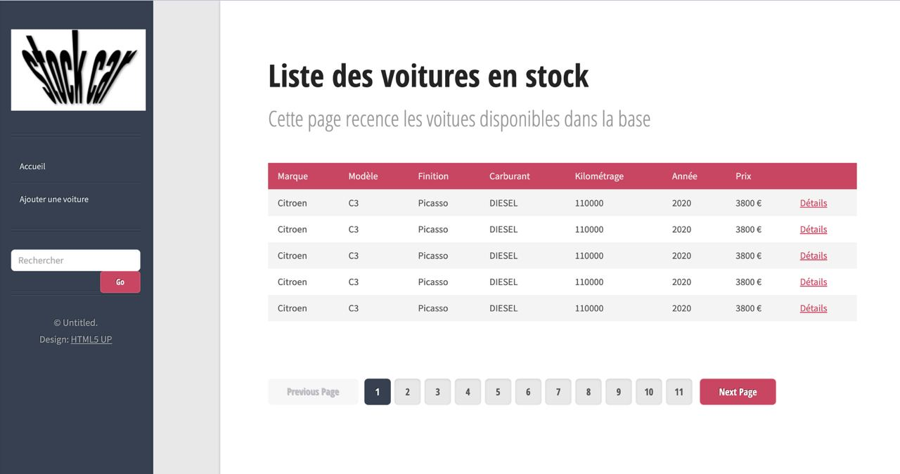

#### **Postcondition**:

The homepage of the web application is accessible, fully loaded, and functional.

**Test Case 2: Adding a New Car**

**Objective:** To verify that the add a car functionality is accessible and that the form for adding a new car opens correctly.

**Precondition**:

* The user is on the homepage of the car stock system.

#### **Test Steps:**

1. **Navigate to the Homepage**:
   * Open the homepage of the web application.
2. **Open the "Add a Car" Section**:
   * Locate the button labeled "Ajouter une voiture" (typically found in the navigation menu or as a button on the homepage).
   * Click on the "Ajouter une voiture" button.

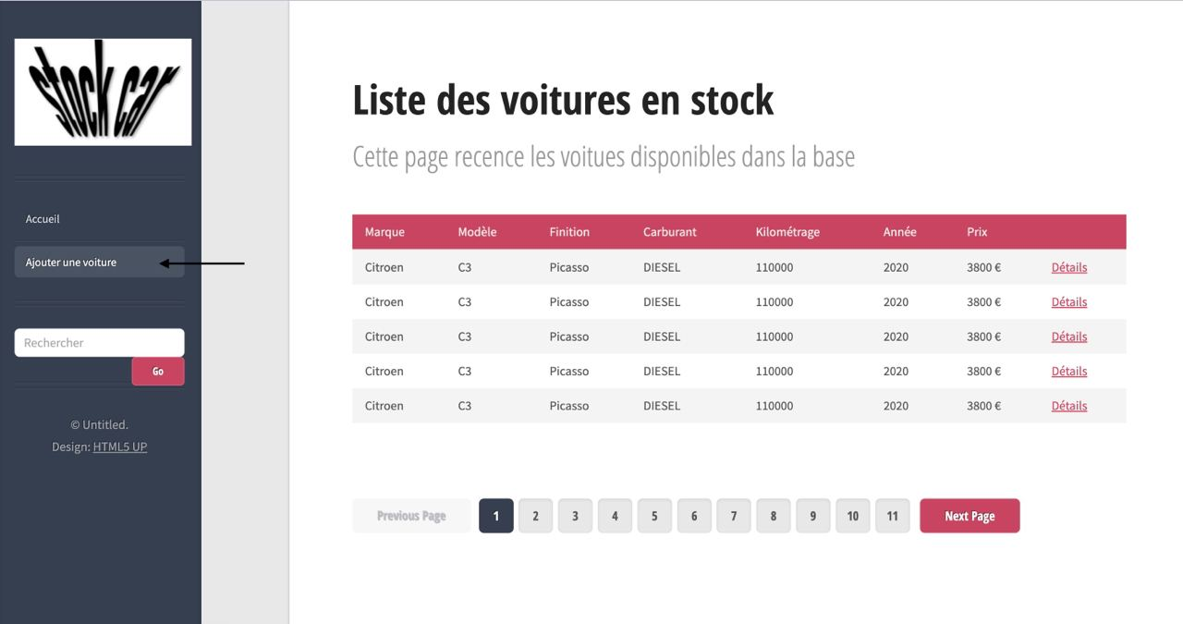

1. **Verify the Form Opens**:
   * Observe that a new page opens.
   * The form should display fields for entering car details such as brand, model, year, mileage, fuel type, and price, finition.

#### **Expected Result:**

* The add car form opens without any errors or delays.
* The form contains the correct fields and labels for adding a new car to the system.

**Actual Result:**

* The add car form opens without any errors or delays.
* The form contains the correct fields and labels for adding a new car to the system.

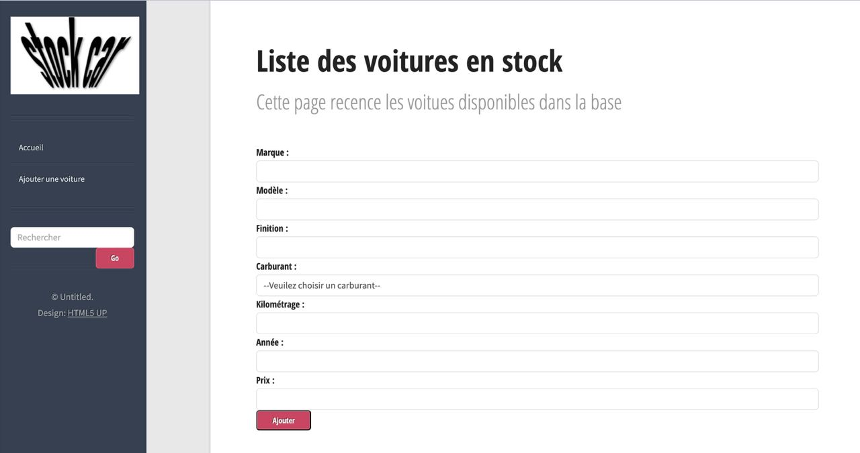

**Test Case 3: Adding a New Car**

**Objective**:  
To verify that a user can successfully add a new car and that the car is visible in the system's car list after submission.

**Precondition**:

* The user is on the homepage of the car management system.

#### **Test Steps:**

1. **Open the add a car section**:
   * Navigate to the homepage of the web application.
   * Locate and click on the "Ajouter une voiture" button.
2. **Enter Car Details**:
   * Fill in the required fields in the form:
     + Brand
     + Model
     + Year
     + Mileage
     + Fuel Type
     + Price
     + Finition

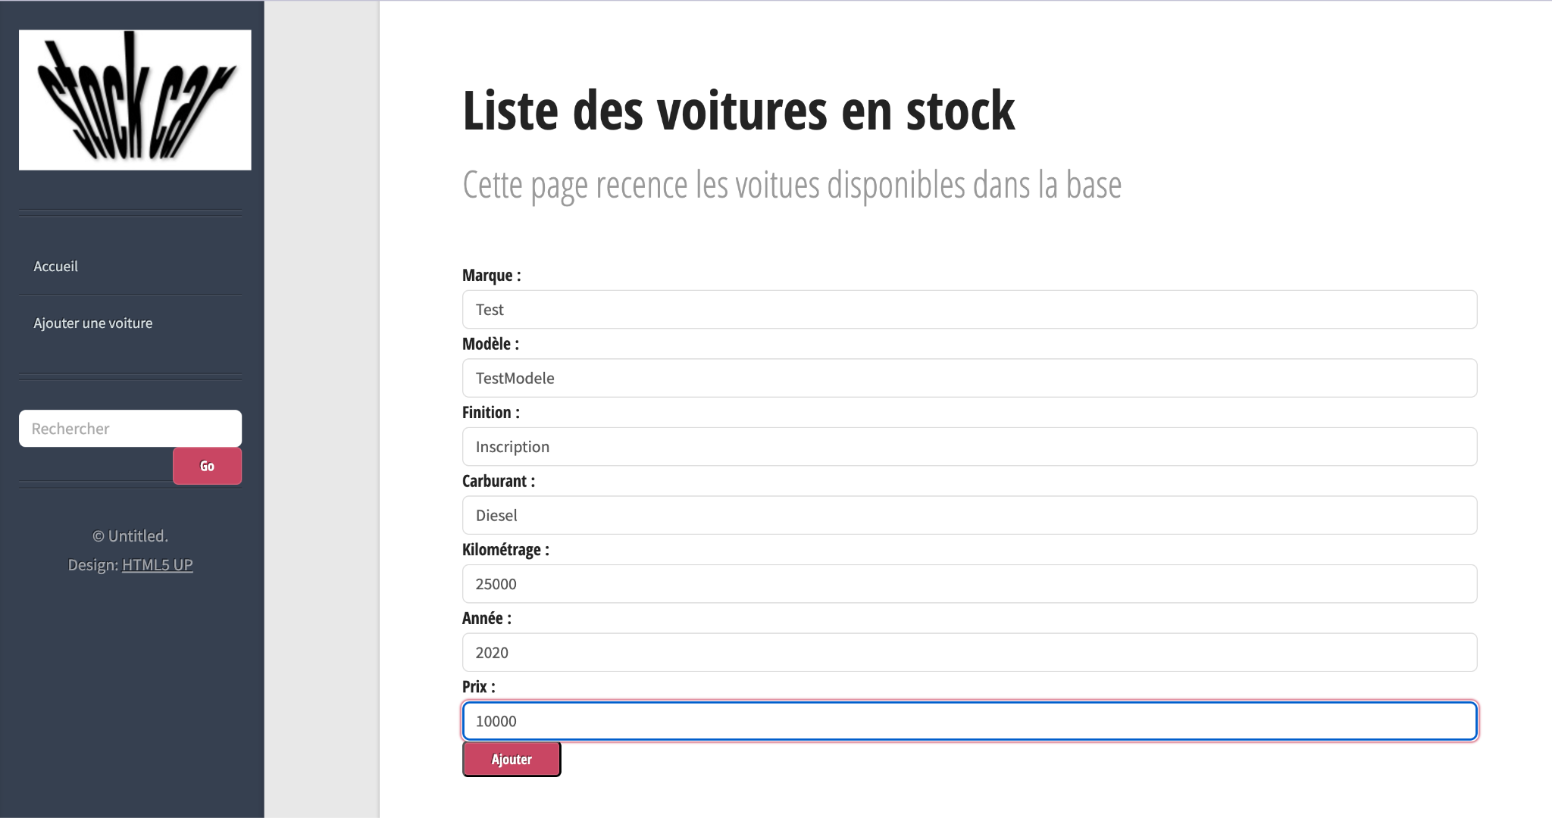

1. **Submit the Form**:
   * Click on the "Ajouter" button to submit the new car information.
2. **Verify Car is Added**:
   * After submission, navigate to the list of all cars in the system.
   * Confirm that the newly added car (with the details entered) appears in the list.

#### **Expected Result:**

* The system successfully saves the new car data.
* The car is visible in the list of all cars with correct details.

#### **Actual Result:**

* The system successfully saved the new car data.
* The car is visible in the list of all cars with correct details.

#### **Postcondition:**

The new car is added to the system and displayed in the list for future interactions.

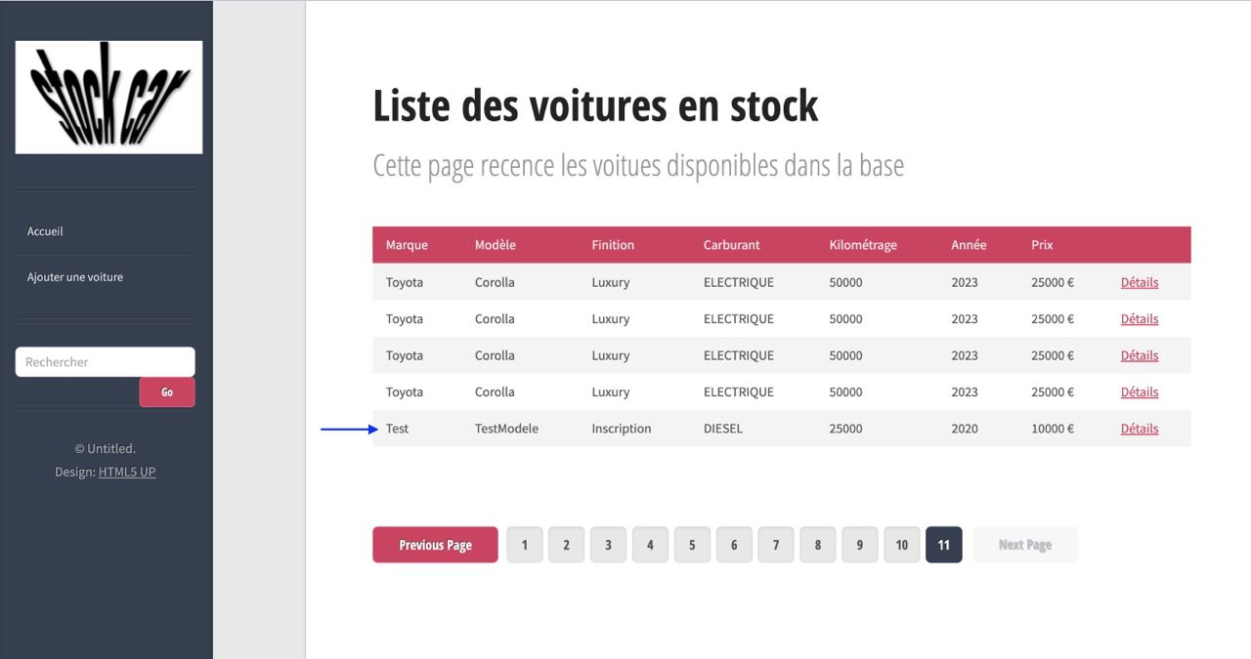

**Test Case 4: Deleting a Car**

**Objective**: To verify that a user can successfully delete a car and that the deleted car is no longer visible in the system's car list.

**Precondition**:

* There is a car with the keyword "Test" available in the system.

#### **Test Steps:**

1. **Search for the Car**:
   * On the homepage, locate the search field.
   * Enter "Test" in the search field and click the "Go" button.
2. **View Details of the Car**:
   * From the search results, find the car entry labeled "Test".

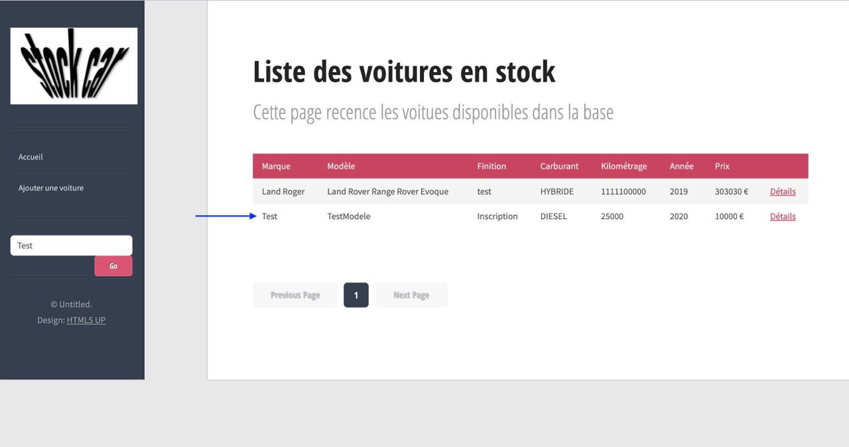

* + Click on the "Details" button next to this car to open the detailed information page.

1. **Delete the Car**:
   * In the car details form, locate and click the "Supprimer" (Delete) button.

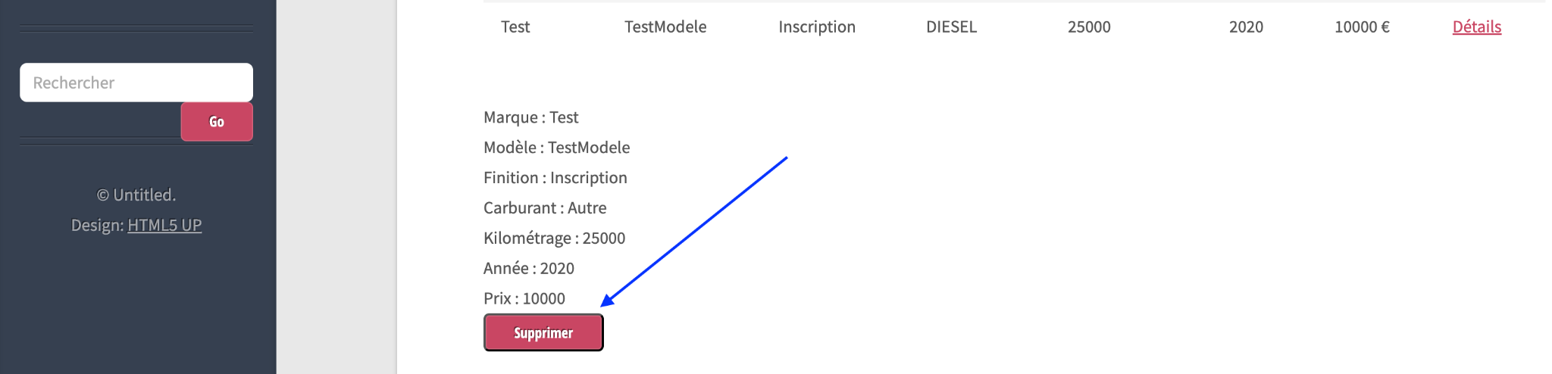

1. **Verify Car Deletion**:
   * After deleting, return to the search field on the homepage.
   * Enter "Test" again and search.

#### **Expected Result:**

* The car record is successfully deleted from the system.
* When searching for "Test", the system no longer shows the car in the results.

#### **Actual Result:**

* The car record is successfully deleted from the system.
* When searching for "Test", the system no longer shows the car in the results.

#### **Postcondition:**

The car is removed from the system and is no longer available for further actions or viewing.

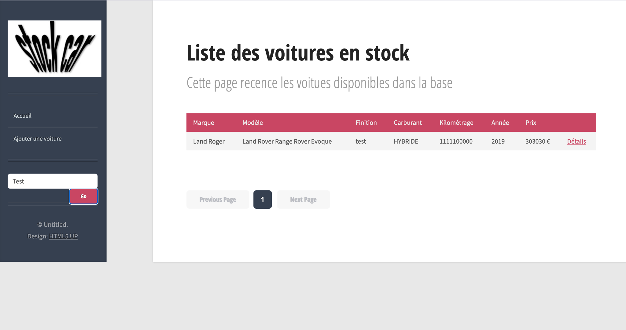

**Test Case 5: Pagination**

**Objective:** To verify the pagination functionality by ensuring that users can navigate to the last page of records and that the navigation buttons behave as expected.

**Precondition:**

* There are a total of 11 pages of records available.

#### **Test Steps:**

1. **Open the Homepage:**
   * Navigate to the homepage of the application, confirming that the pagination displays a total of 11 pages.

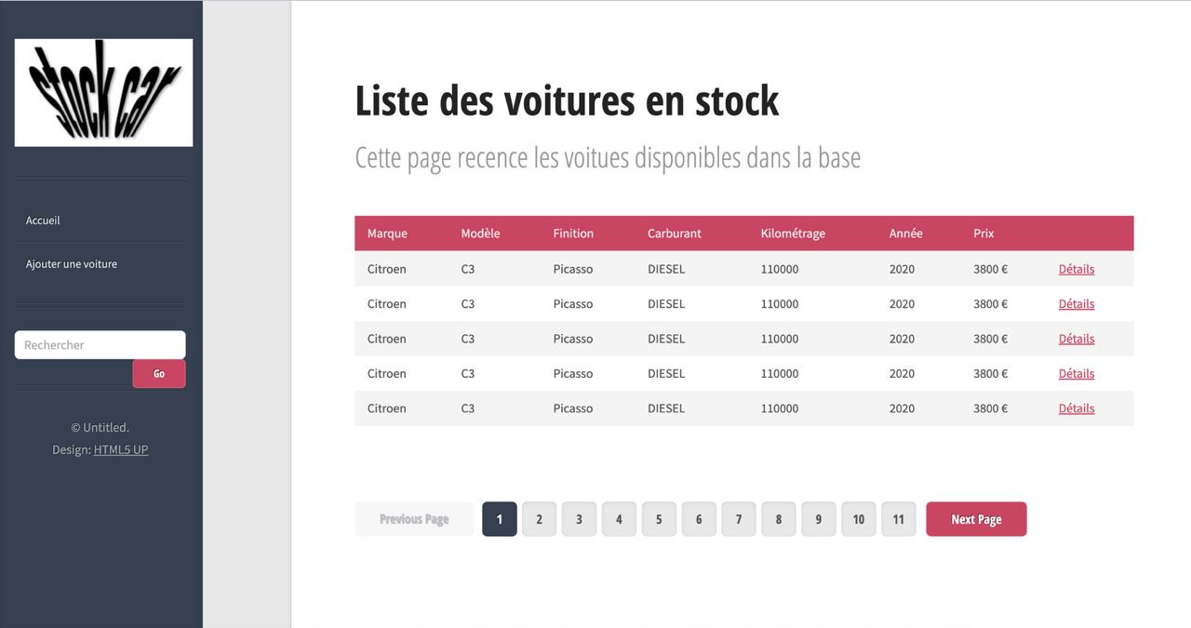

1. **Navigate to the Last Page:**
   * Locate the pagination controls on the page.
   * Click on the button or link corresponding to the last page.

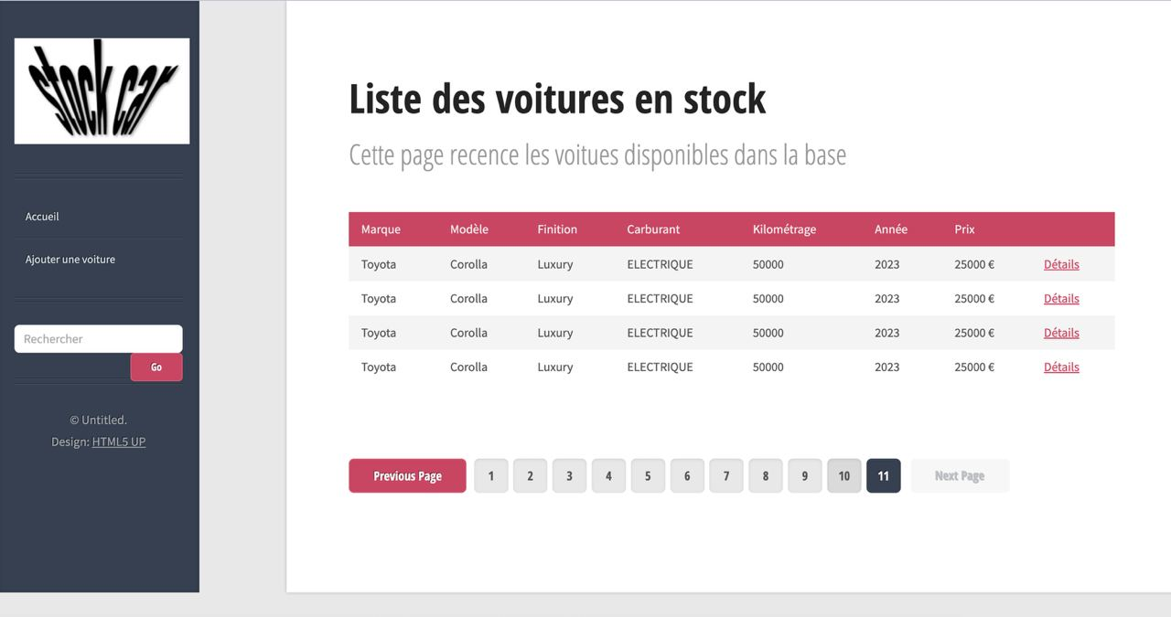

#### **Expected Result:**

* The application should load the last page of records, displaying four entries.
* The "Previous Page" button should become clickable and highlighted in red, indicating that users can navigate back to the previous page.
* The "Next Page" button should be disabled and grayed out, indicating that there are no additional pages beyond the last page.

#### **Actual Result:**

* The application loaded the last page of records, displaying four entries.
* The "Previous Page" button became clickable and highlighted in red, indicating that users can navigate back to the previous page.
* The "Next Page" button is disabled and grayed out, indicating that there are no additional pages beyond the last page.

#### **Postcondition:**

The user is able to view the records on the last page, with clear visual indicators of available navigation options.



### **7. Integration Tests**

### **Test Case: Adding a New Car and Search Scenario (testAjouterVoiture)**

#### **Objective:**

To verify that a new car can be successfully added to the database and retrieved correctly.

#### **Preconditions:**

* The database connection is established.

#### **Test Steps:**

1. **Create a New Car Instance**:
   * Instantiate a new Voiture object.
   * Set the following properties for the Voiture instance:
     + Marque: "TeslaTest"
     + Modele: "Model S"
     + Finition: "Sport"
     + Carburant: Carburant.DIESEL
     + Km: 50000
     + Annee: 2020
     + Prix: 70000
2. **Add the New Car to the Database**:
   * Call the ajouterVoiture method of the voitureDAO object, passing in the voiture instance to insert it into the database.
3. **Search for the Newly Added Car**:
   * Call the rechercherVoitures method of the voitureDAO object with the search parameter "TeslaTest" and pagination parameters (0, 10) to retrieve the list of cars.
4. **Verify the Response**:
   * Assert that the reponseVoiture object is not null, indicating that a response was received.
   * Assert that the data array in reponseVoiture is not null, ensuring that there are records returned.
   * Assert that the first element of the data array matches the properties of the newly added car:
     + Marque should be "TeslaTest".
     + Modele should be "Model S".
     + Finition should be "Sport".
     + Carburant should be Carburant.DIESEL.
     + Km should be 50000.
     + Annee should be 2020.
     + Prix should be 70000.
   * Assert that the volume of reponseVoiture equals 1, confirming that one record was found.

#### **Expected Result:**

* The new car should be added to the database successfully.
* The search should return the newly added car with all properties matching the input values.
* The volume of results returned should indicate that one matching record was found.

#### **Postcondition:**

* The newly added car remains in the database and can be retrieved in subsequent operations.

**Test code:**

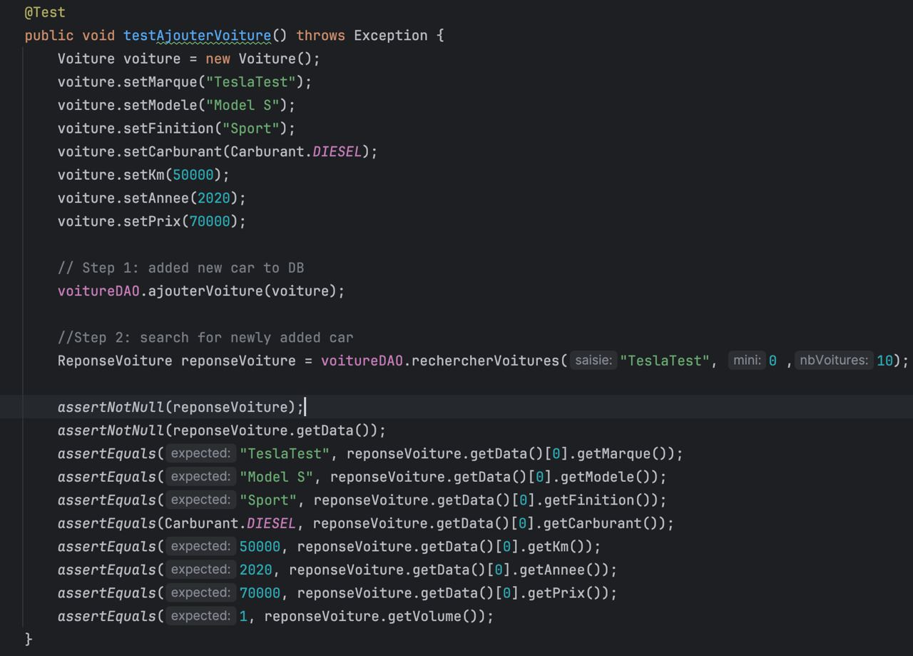

**Execution Result:**  
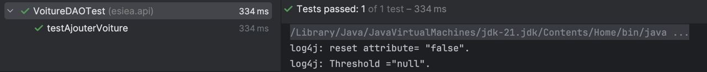

### **Test Case: Adding and Deleting a Car scenario (testSupprimeVoiture)**

#### **Objective:**

To verify that a car can be successfully added and then deleted from the database and that it no longer appears in subsequent searches.

#### **Preconditions:**

* The database connection is established.

#### **Test Steps:**

1. **Create a New Car Instance**:
   * Instantiate a new Voiture object.
   * Set the following properties for the Voiture instance:
     + Marque: "TeslaTest"
     + Modele: "Model S"
     + Finition: "Sport"
     + Carburant: Carburant.DIESEL
     + Km: 50000
     + Annee: 2020
     + Prix: 70000
2. **Add the New Car to the Database**:
   * Call the ajouterVoiture method of the voitureDAO object, passing in the voiture instance to insert it into the database.
3. **Search for the Newly Added Car**:
   * Call the rechercherVoitures method of the voitureDAO object with the search parameter "TeslaTest" and pagination parameters (0, 10) to retrieve the list of cars.
4. **Verify the Response Before Deletion**:
   * Assert that the reponseVoiture object is not null, indicating that a response was received.
   * Assert that the data array in reponseVoiture is not null, ensuring that there are records returned.
   * Assert that the first element of the data array matches the properties of the newly added car:
     + Marque should be "TeslaTest".
     + Modele should be "Model S".
     + Finition should be "Sport".
     + Carburant should be Carburant.DIESEL.
     + Km should be 50000.
     + Annee should be 2020.
     + Prix should be 70000.
   * Assert that the volume of results returned equals 1, confirming that one record was found.
5. **Delete the Newly Added Car**:
   * Call the supprimerVoiture method of the voitureDAO object, passing in the ID of the car to delete. The ID is retrieved from the first element of the data array.
6. **Search for the Deleted Car**:
   * Call the rechercherVoitures method of the voitureDAO object again with the same search parameter "TeslaTest" and pagination parameters (0, 10).
7. **Verify the Response After Deletion**:
   * Assert that the reponseVoitureAfterDelete object is not null, indicating that a response was received.
   * Assert that the data array in reponseVoitureAfterDelete is not null, ensuring that there are records returned.
   * Assert that the volume of results returned equals 0, confirming that no records were found after the deletion.

#### **Expected Result:**

* The new car should be added to the database successfully.
* The search before deletion should return the newly added car with all properties matching the input values and a volume of 1.
* The deletion operation should successfully remove the car from the database.
* The subsequent search after deletion should return a volume of 0, indicating that the car no longer exists in the database.

#### **Postcondition:**

* The car identified by the specified ID is removed from the database, and it cannot be retrieved in subsequent operations.

**Test code:**

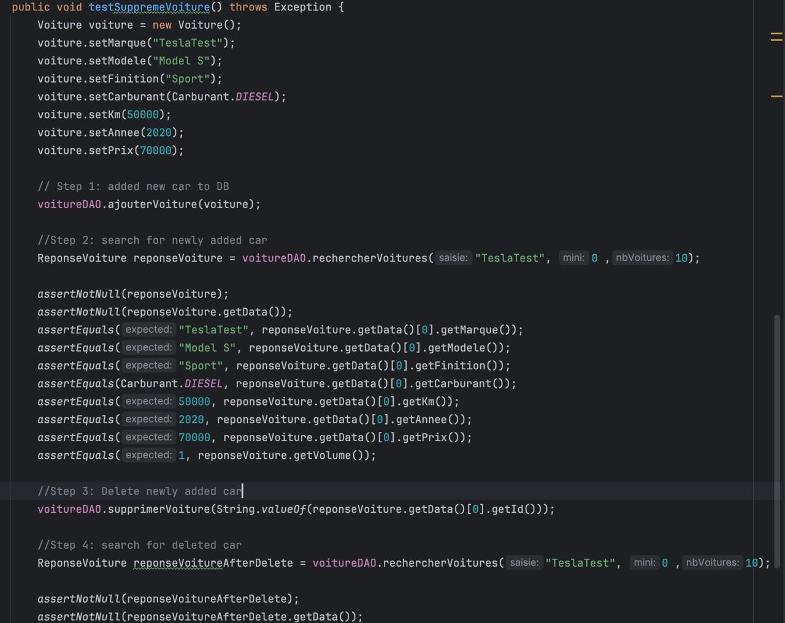

**Execution Result:**



**8. Anomalies**

Several critical anomalies have been identified within the application that require immediate attention to enhance both functionality and security. One significant issue arises from the **search functionality, where any numerical input is interpreted solely as an ID.** This limitation significantly restricts the user’s ability to search for cars by other relevant criteria, such as year, mileage, or price. For instance, if a user intends to find cars with a specific mileage or within a certain price range, they may inadvertently input a number only to receive incorrect results or no results at all. This can lead to user frustration and dissatisfaction, ultimately affecting user retention and engagement. Additionally, it can create a situation where potential buyers miss out on suitable vehicles because the search feature does not accommodate their specific needs.

To mitigate this issue, the search feature should be redesigned to include distinct fields for entering search criteria by ID, year, mileage, and price. Implementing filters or dropdown menus would allow users to easily specify their search parameters. This enhancement would not only improve the user experience but also increase the likelihood of users finding relevant cars that meet their criteria.

Another severe concern is the **lack of authentication and authorization features** within the application. Currently, any user can add, delete, or modify car records without restriction. This poses a significant security risk, as unauthorized users could maliciously delete cars from the database or add inaccurate or fraudulent information. For example, a malicious actor could enter fictitious car records, leading to a misrepresentation of inventory or skewed statistics that impact business decisions. Additionally, the absence of user verification could result in scenarios where a disgruntled employee or a malicious competitor manipulates the data, either intentionally harming the business's reputation or inadvertently causing data integrity issues.

To address these vulnerabilities, it is crucial to implement a robust user authentication system. This system should verify the identity of users through secure login credentials, ensuring that only authorized individuals can access sensitive functionalities such as adding or deleting car records. Moreover, implementing role-based access control would allow for granular permissions, enabling certain users to have administrative privileges while restricting others to viewing capabilities. This approach would protect the application from unauthorized actions, preserve the integrity of the data, and instill greater confidence in users regarding the reliability of the platform.

In conclusion, by addressing these anomalies—enhancing the search functionality and instituting a secure authentication and authorization system—the application can significantly improve user experience, maintain data integrity, and safeguard against potential misuse or malicious activities.